**Bhargavi Moram**

**999992733**

**Lab 1**

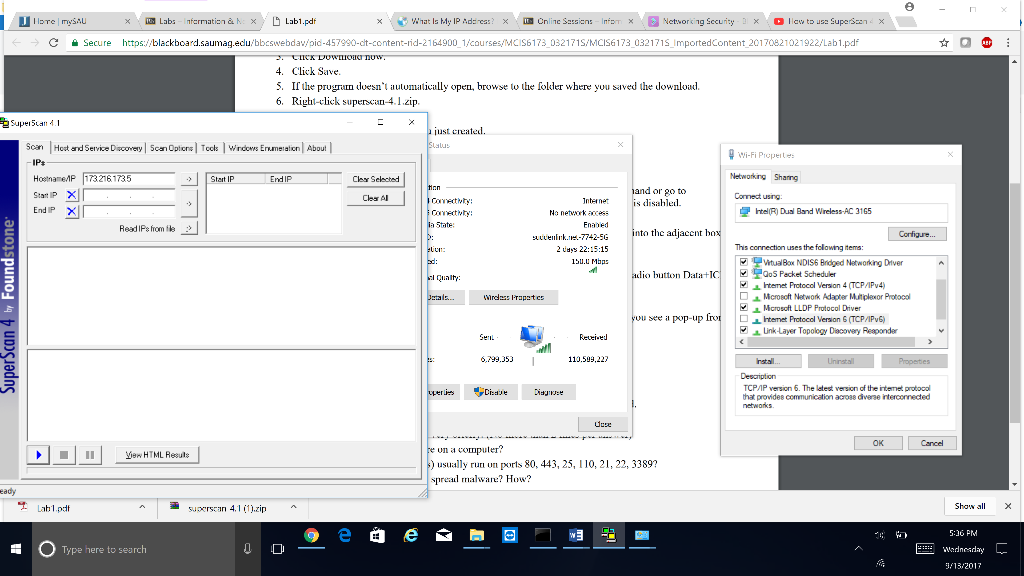

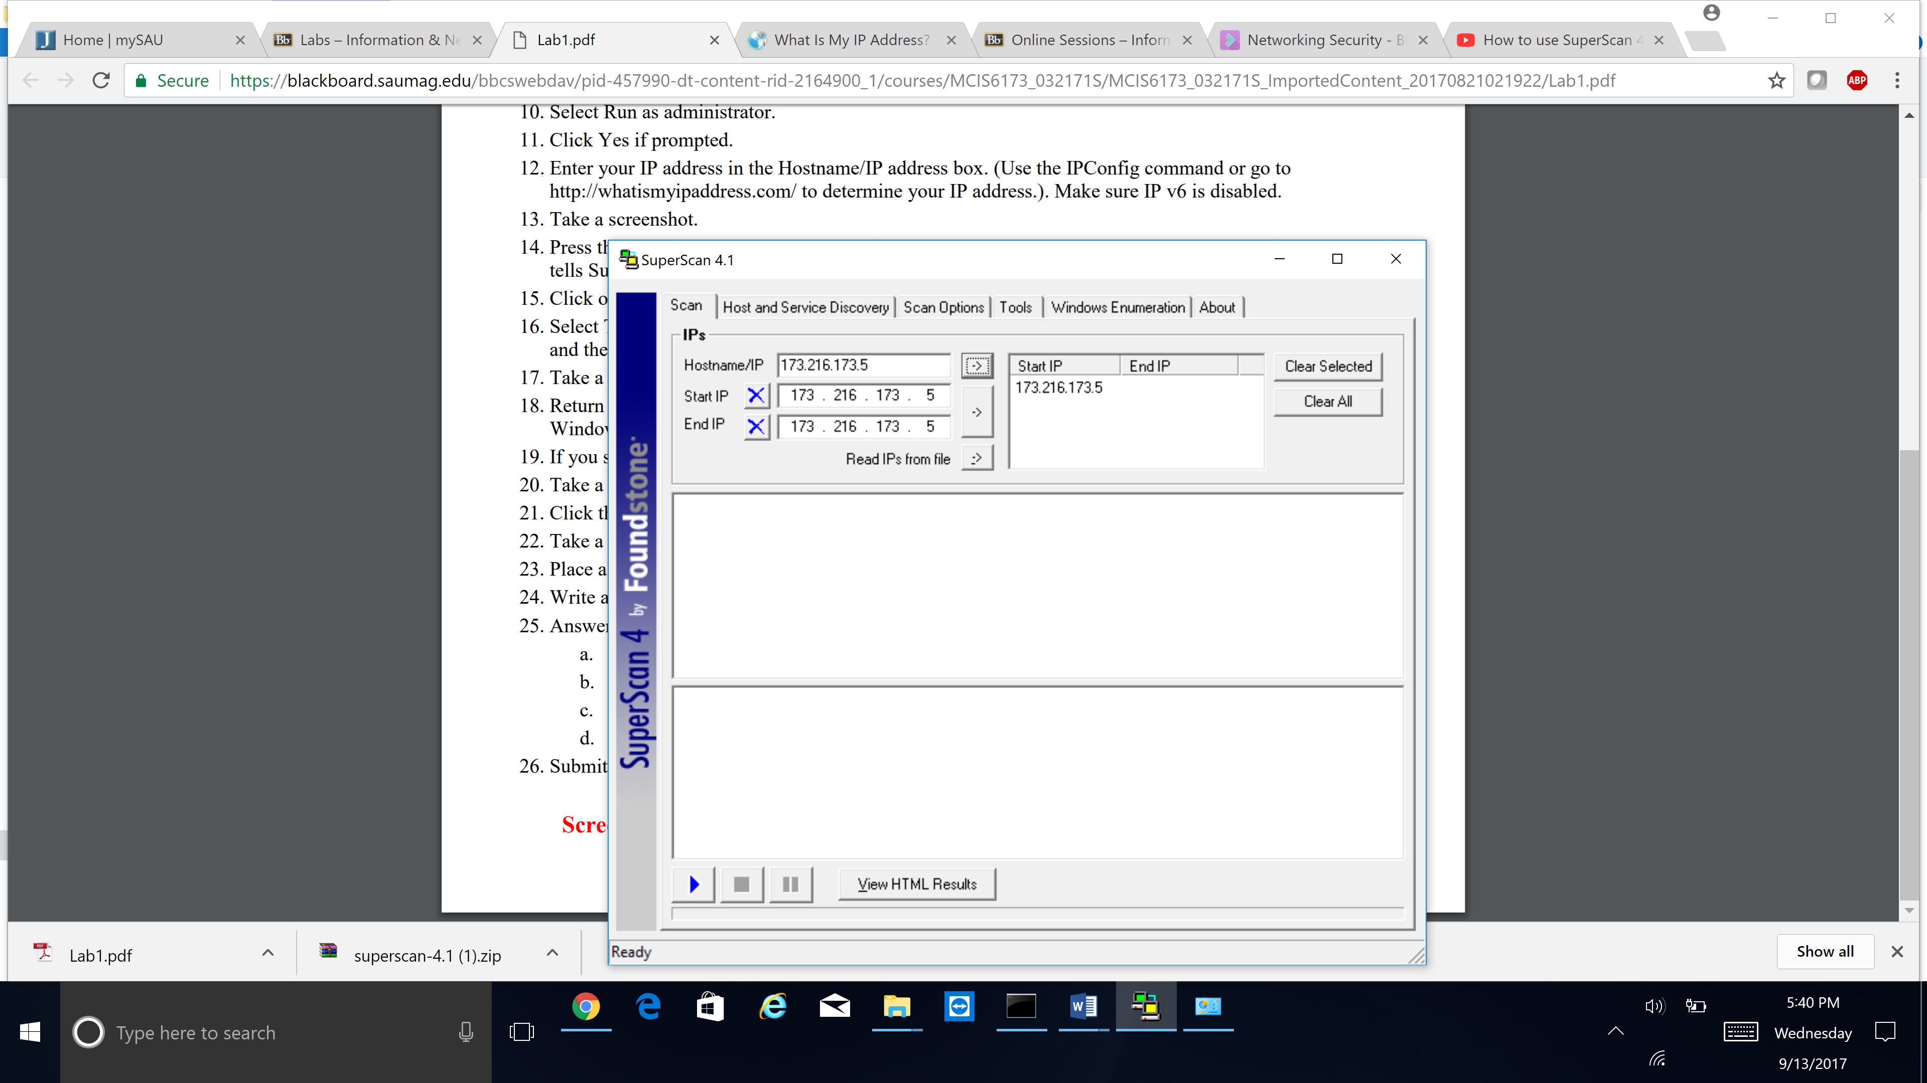

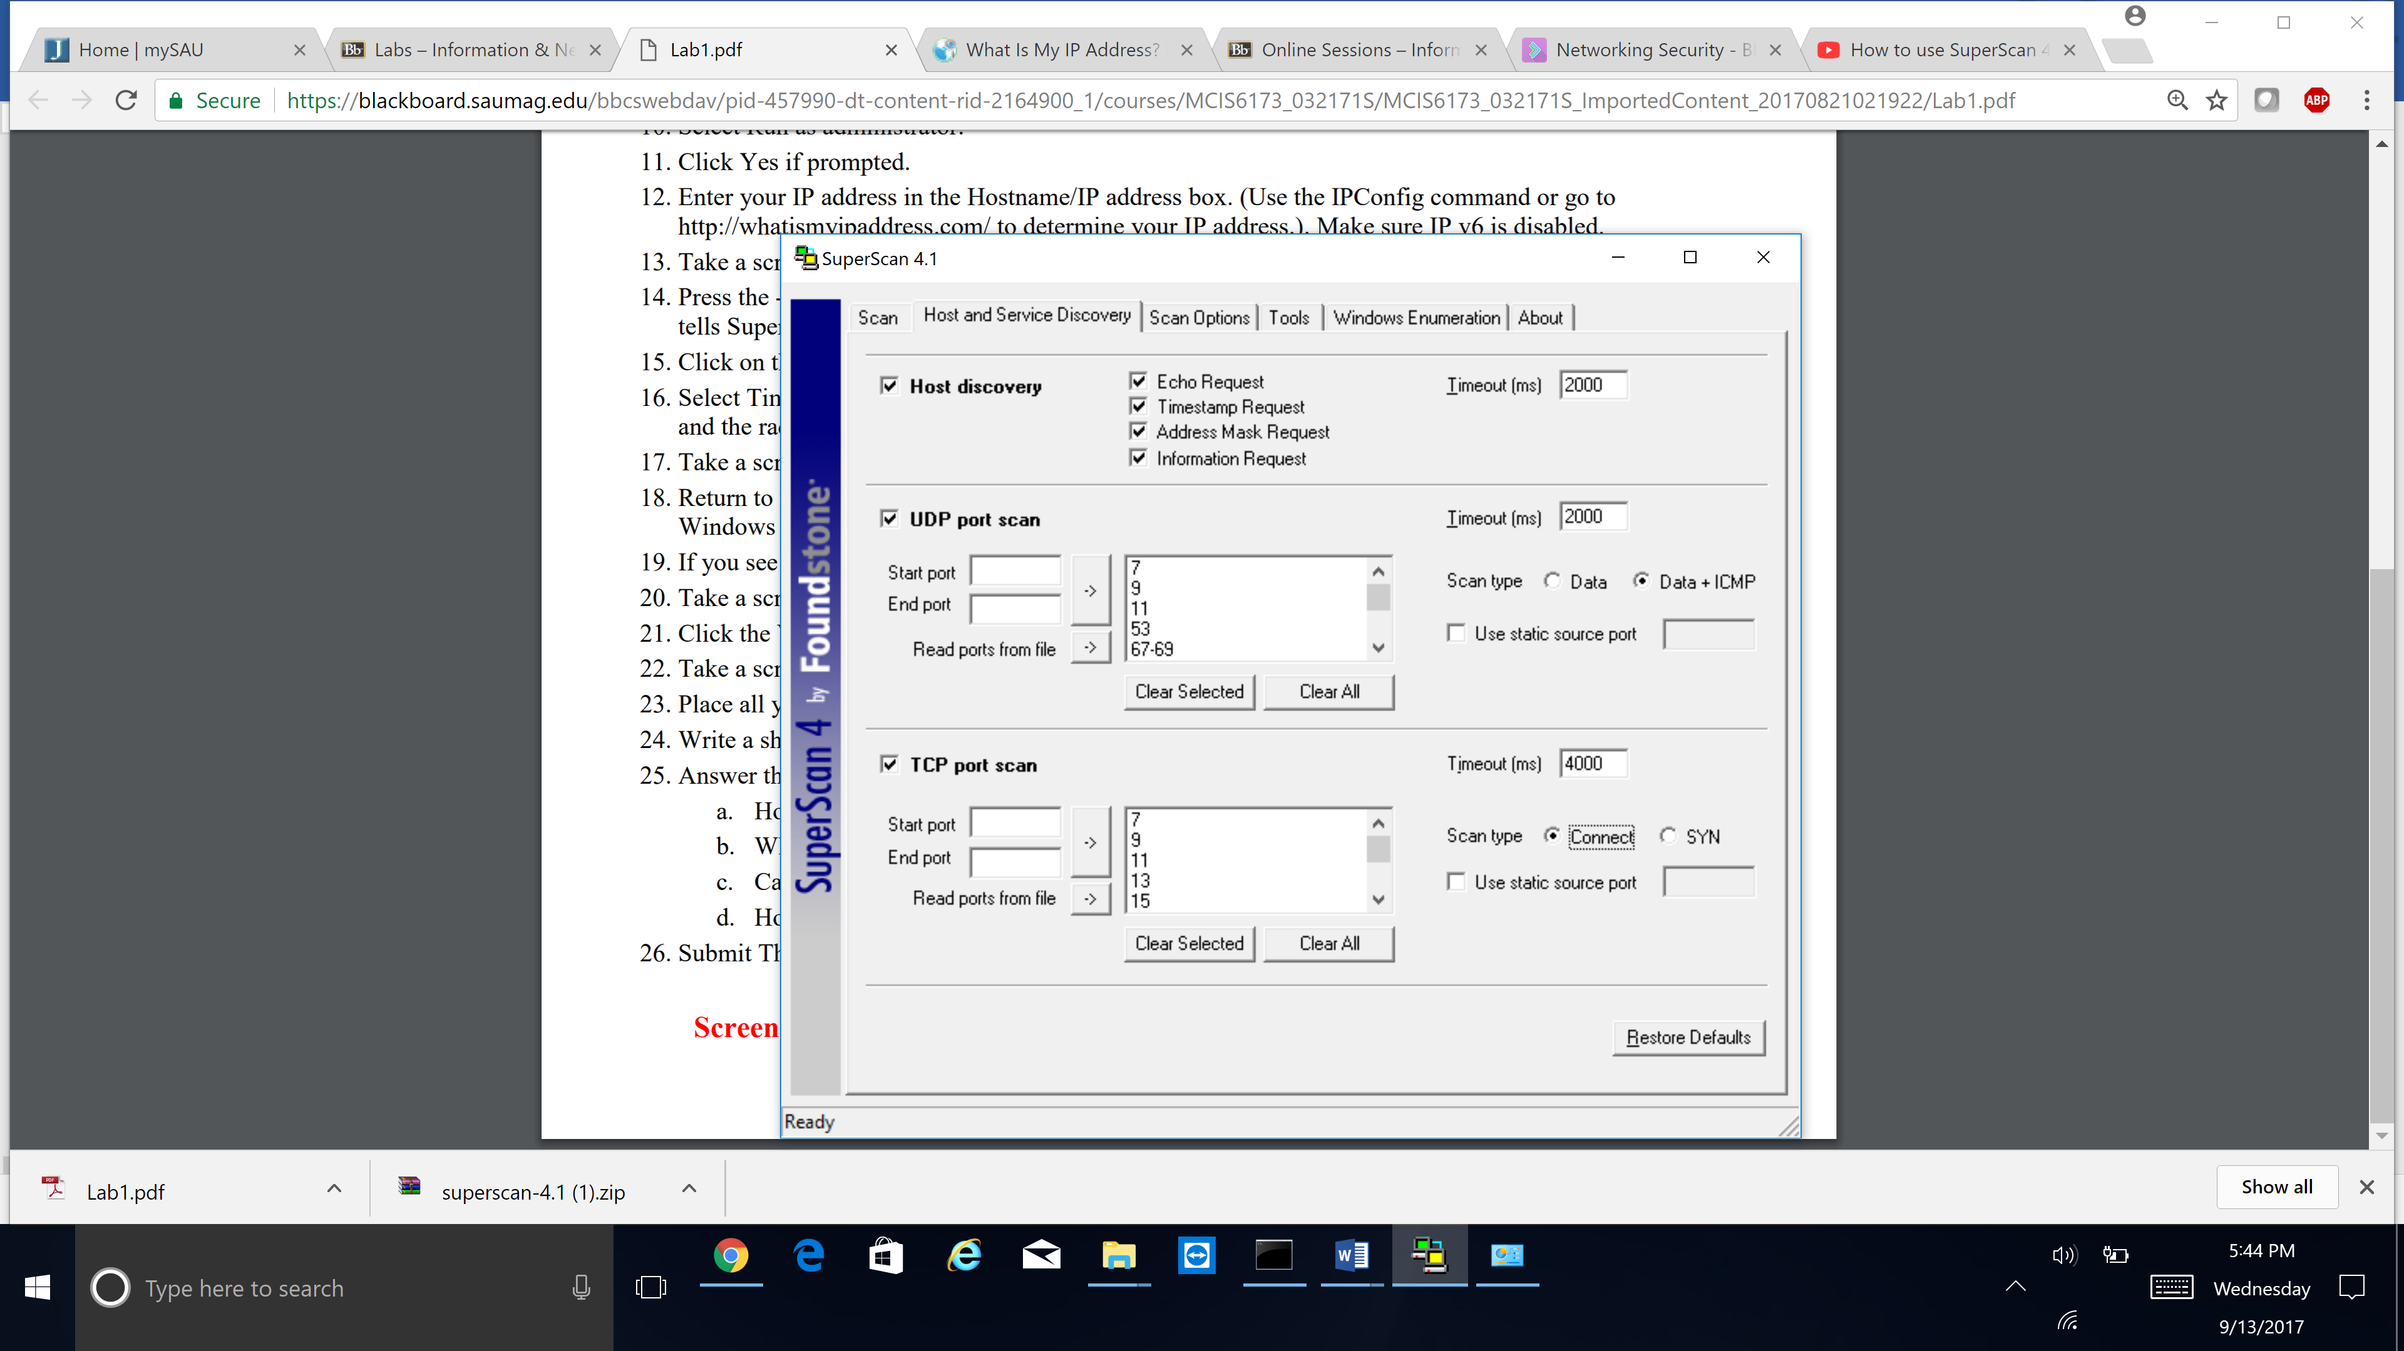

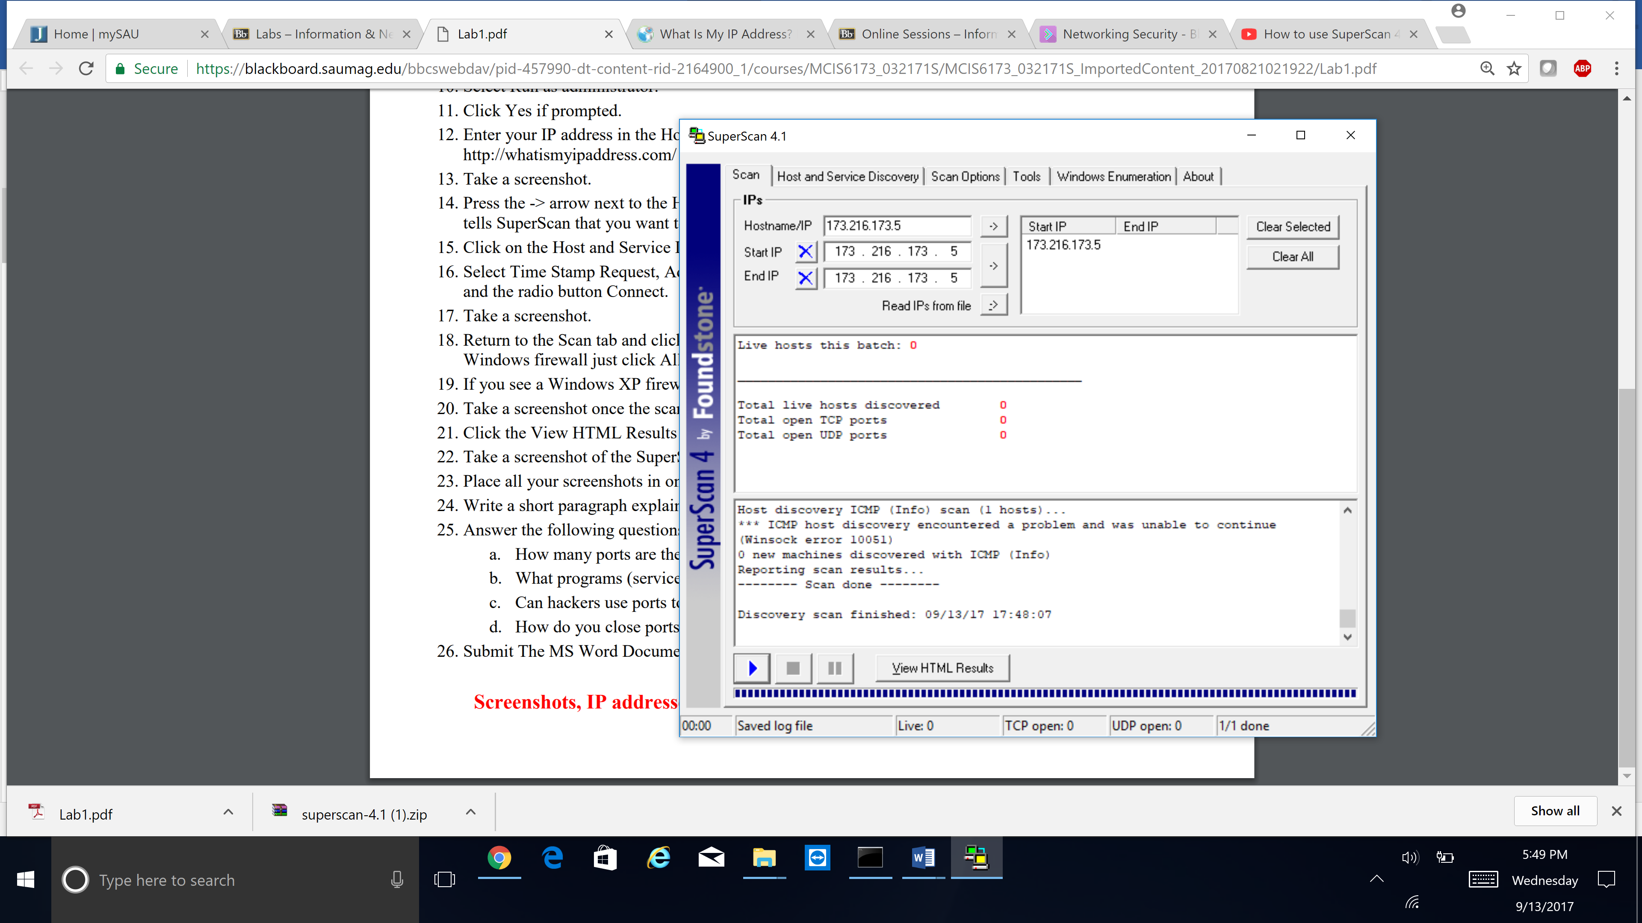

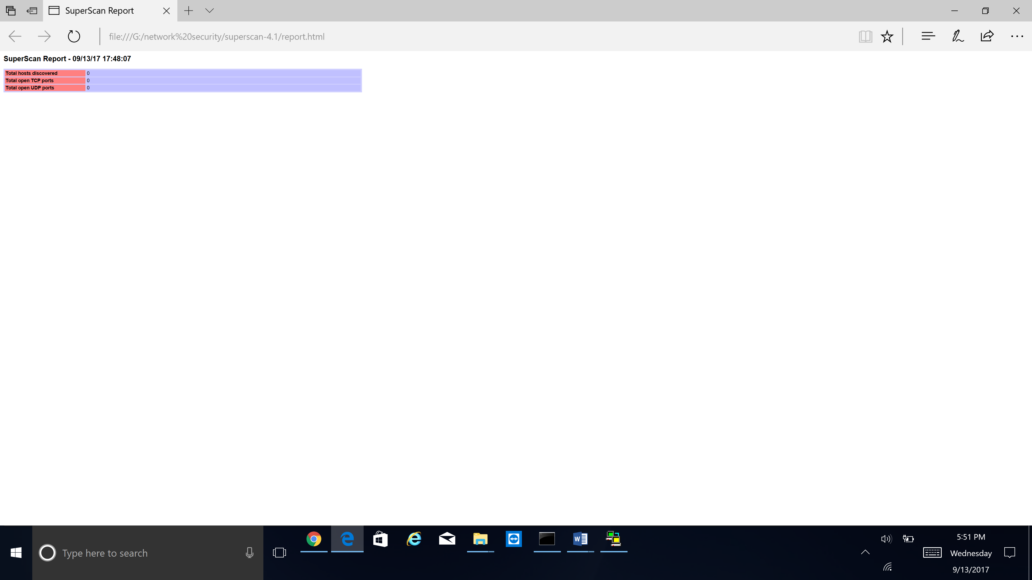

24.

After I have gone through all the steps, I got results‘0’ for total live hosts discovered ,total open TCP ports and total open UDP ports.

**Total live hosts discovered 0**

**Total open TCP ports 0**

**Total open UDP ports 0**

25.

A.

Transport layer protocols, such as the Transmission Control Protocol (TCP) and the User Datagram Protocol (UDP), specify a source and destination port number in their headers. A port number is a **16**-bit unsigned integer, thus ranging from **0** to **65535**. **There are** **65,536 ports on a computer.**

B.

80 HTTP (HyperText Transfer Protocol) service use port 80

443 SSL (Secure Socket Layer) service use port 443

25 SMTP (Send Mail Transfer Protocol) service use port 25

110 POP3 (Post Office Protocol, version 3) service use port 110

21 FTP (File Transfer Protocol) service use port 21total

22 SSH (Secure Shell) service use port 22

Remote Desktop Protocol service use port 3389

C. Yes, certain types of malware are known to access computers through specific ports.

D. You can remove the program that opened the port, or you can set your firewall to block that specific port